**ASSIGNMENT 1 FRONT SHEET**

|  |  |  |  |
| --- | --- | --- | --- |
| **Qualification** | **BTEC Level 5 HND Diploma in Computing** | | |
| **Unit number and title** |  | | |
| **Submission date** |  | **Date Received 1st submission** |  |
| **Re-submission Date** |  | **Date Received 2nd submission** |  |
| **Student Name** | NGUYEN HUU HOANG | **Student ID** | BDAF190022 |
| **Class** | BH-AF-2005-2.3 | **Assessor name** | NGO THI MAI LOAN |
| **Student declaration**  I certify that the assignment submission is entirely my own work and I fully understand the consequences of plagiarism. I understand that making a false declaration is a form of malpractice. | | | |
|  |  | **Student’s signature** |  |

**Grading grid**

|  |  |  |  |  |  |  |  |
| --- | --- | --- | --- | --- | --- | --- | --- |
| P1 | P2 | P3 | M1 | M2 | M3 | D1 | D2 |
|  |  |  |  |  |  |  |  |

|  |  |  |
| --- | --- | --- |
| **❒ Summative Feedback: ❒ Resubmission Feedback:** | | |
| **Grade:** | **Assessor Signature:** | **Date:** |
| **Signature & Date:** | | |

Contents

# LO1 EXAMINE ABSTRACT DATA TYPES, CONCRETE DATA STRUCTURES AND ALGORITHMS

# INTRODUCTION

# CONTENT

# I. CREATE A DESIGN SPECIFICATION FOR DATA STRUCTURES EXPLAINING THE VALID OPERATIONS THAT CAN BE CARRIED OUT ON THE STRUCTURES (P1)

Queues are an essential data structure that is found in vast amounts of software from user mode to kernel mode applications that are core to the system.

Fundamentally they honors a first in first out (FIFO) strategy, that is the item first put into the queue will be the first served, the second item added to the queue will be the second to be served and so on.

A traditional queue only allows you to access the item at the front of the queue; when you add an item to the queue that item is placed at the back of the queue.

Historically queues always have the following three core methods:

==========

Enqueue: places an item at the back of the queue;

Dequeue: retrieves the item at the front of the queue, and removes it from the queue;

Peek: Retrieves the item at the front of the queue without removing it from the queue

The following image shows a conceptual image of a queue. The front of the queue is where items are removed and the back of the queue is where items are added.

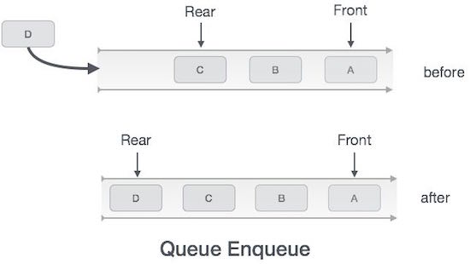

2. Circular array queue

During this read, we will create a circular array queue with maximum capacity. This should give us an idea of how queuing is implemented outside of academia. Capacity is a very real limitation.

The following image is a visual aid of how circular array queues work:

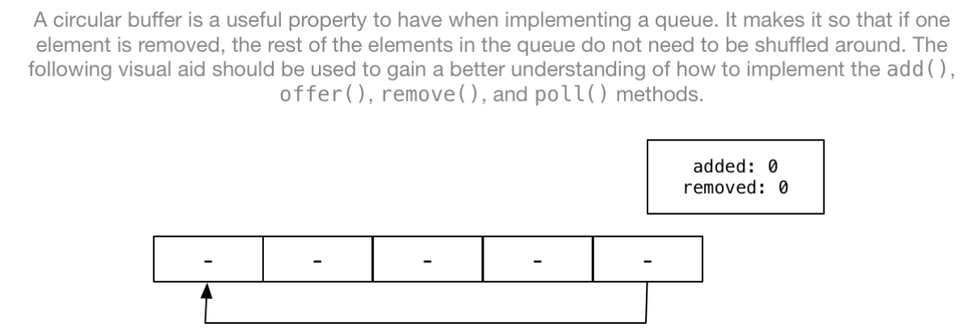

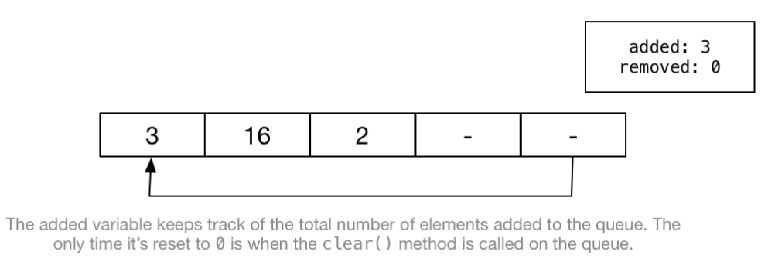

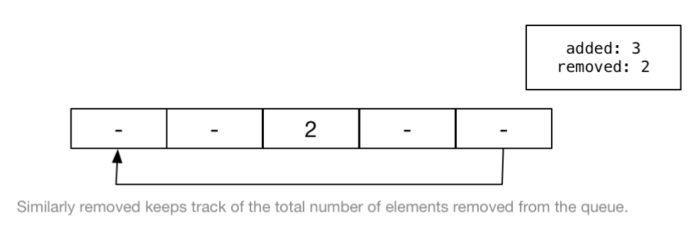

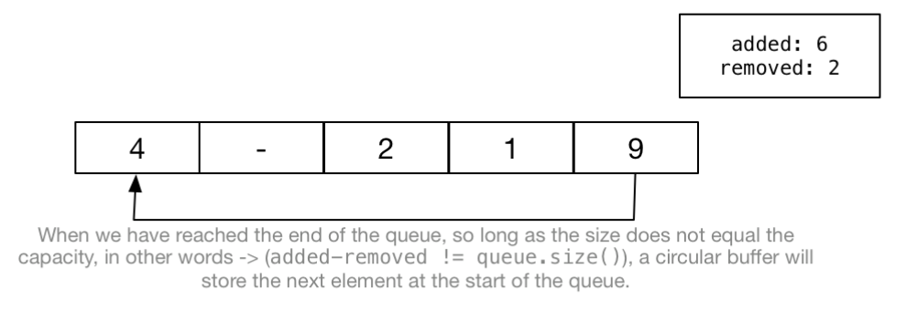

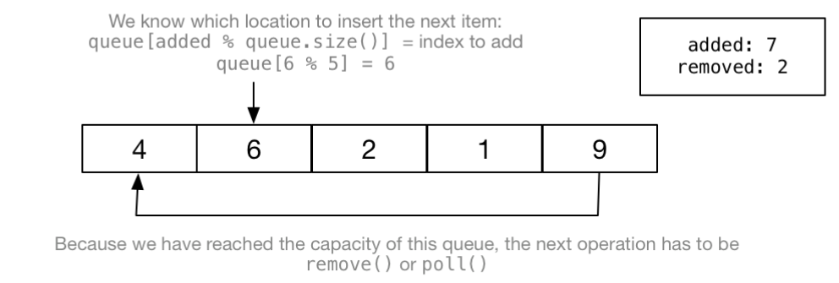

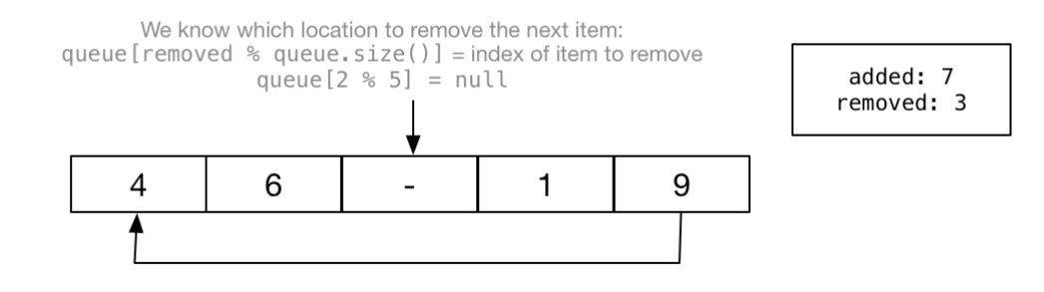

# II. DETERMINE THE OPERATIONS OF A MEMORY STACK AND HOW IT IS USED TO IMPLEMENT FUNCTION CALLS IN A COMPUTER (P2)

# III. ILLUSTRATE, WITH AN EXAMPLE, A CONCRETE DATA STRUCTURE FOR A FIRST IN FIRST OUT (FIFO) QUEUE (M1)

# IV. COMPARE THE PERFORMANCE OF TWO SORTING ALGORITHMS (M2)

Giải thuật sắp xếp

Sắp xếp là sắp xếp dữ liệu theo một định dạng cụ thể như theo thứ tự anphabet tăng/giảm dần, theo thứ tự số tăng/giảm dần. Trong khoa học máy tính, giải thuật sắp xếp xác định cách để sắp xếp dữ liệu theo một thứ tự nào đó. Sắp xếp theo thứ tự ở đây là sắp xếp theo thứ tự dạng số hoặc thứ tự dạng chữ cái như trong từ điển.

Tính quan trọng của việc sắp xếp dữ liệu nằm ở chỗ: việc tìm kiếm dữ liệu có thể được tối ưu nếu dữ liệu được sắp xếp theo một thứ tự nào đó (tăng hoặc giảm). Sắp xếp cũng được sử dụng để biểu diễn dữ liệu trong một định dạng dễ đọc hơn.

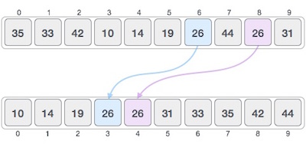

# LO2 SPECIFY ABSTRACT DATA TYPES AND ALGORITHMS IN A FORMAL NOTATION

# I. USING AN IMPERATIVE DEFINITION, SPECIFY THE ABSTRACT DATA TYPE FOR A SOFTWARE STACK (P3)

# II. EXAMINE THE ADVANTAGES OF ENCAPSULATION AND INFORMATION HIDING WHEN USING AN ADT (M3)

# CONCLUSION

# REFERENCES

1. <https://www.cs.colostate.edu/~cs165/.Summer19/recitations/L12/doc/queue.html>

<https://www.geeksforgeeks.org/stack-data-structure/>

thuật toán sắp xếp

<https://viettuts.vn/bai-tap-java/cac-thuat-toan-sap-xep-trong-java>